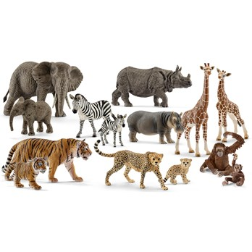 | ANIMAL
 | animal
 | animal
 | animal

