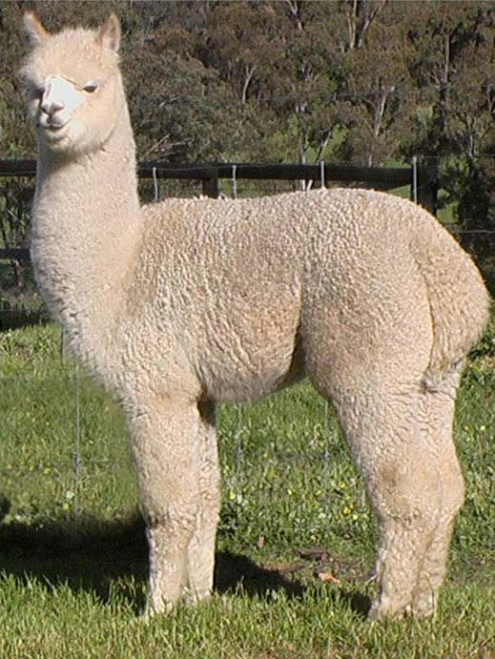 | 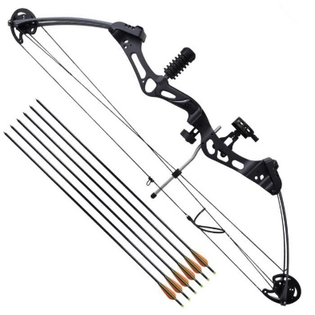
l-m-a-a | r-c-a |  | m-c-i-o-r
L-M-A-A | R-C-A |  | M-C-I-O-R
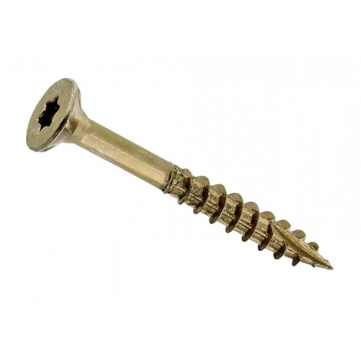 | 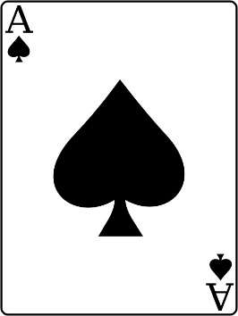 |  | 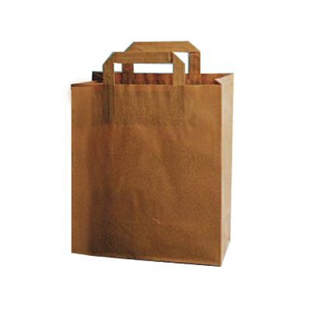
s-v-i | s-a |  | c-s-a
S-V-I | S-A |  | C-S-A
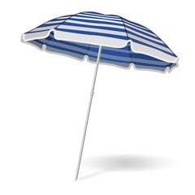 |  |  | 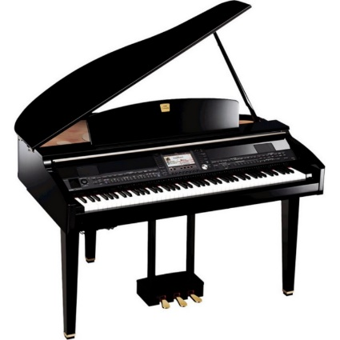
s-o-p-a-l-a-r | b-a-l-a-o-v |  | i-p-o-a-n
S-O-P-A-L-A-R | B-A-L-A-O-V |  | I-P-O-A-N
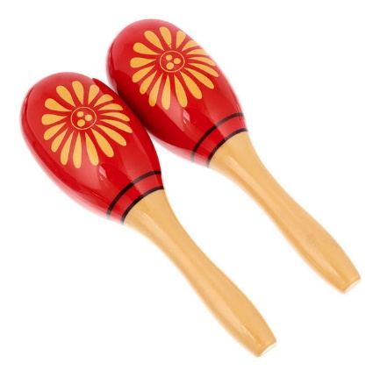 | 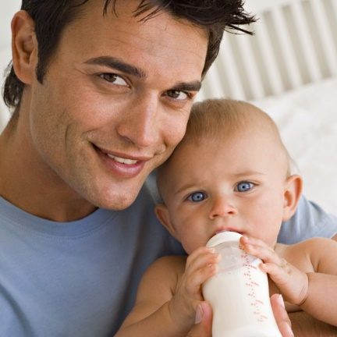 |  | 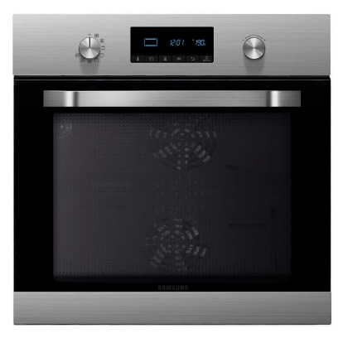
r-a-m-a-s-a-c | é-b-b-é |  | ou-r-f
R-A-M-A-S-A-C | É-B-B-É |  | OU-R-F
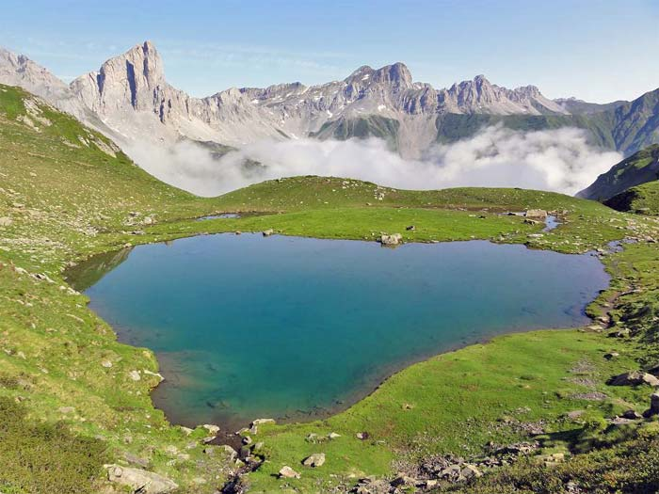 | 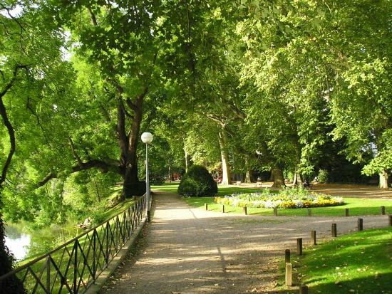 |  | 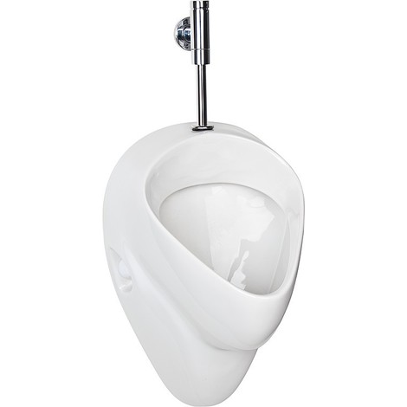
c-l-a | in-ch-e-m |  | n-oi-r-u-i-r
C-L-A | IN-CH-E-M |  | N-OI-R-U-I-R
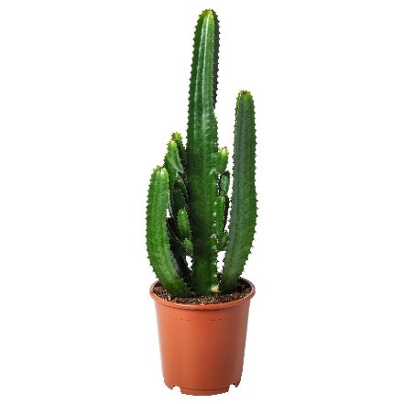 | 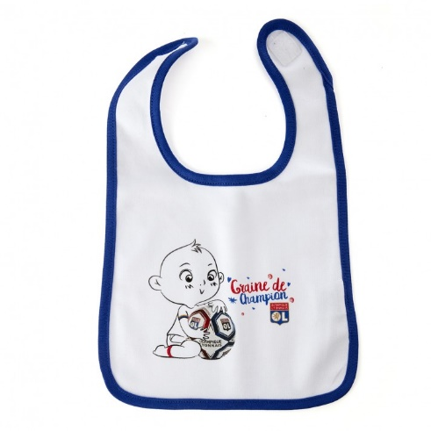 |  | 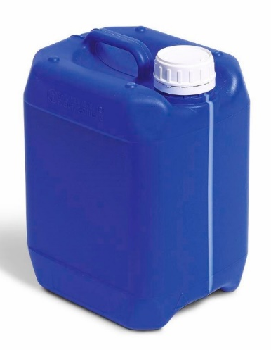
c-t-c-a-u-s | v-b-a-oi-r |  | b-on-i-d
C-T-C-A-U-S | V-B-A-OI-R |  | B-ON-I-D
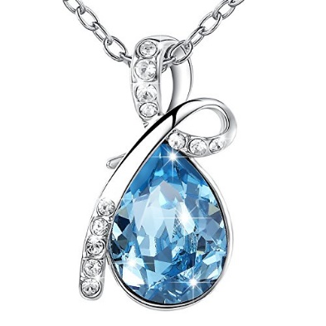 | 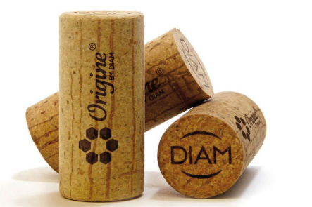 |  | 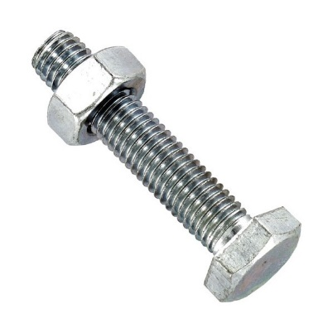
j-b-ou-i | on-ch-b-ou |  | s-i-v
J-B-OU-I | ON-CH-B-OU |  | S-I-V
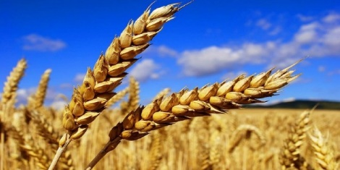 | 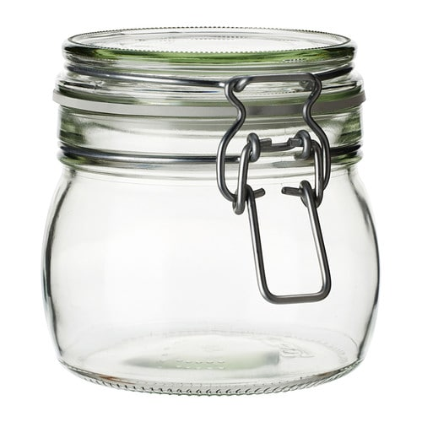 |  | 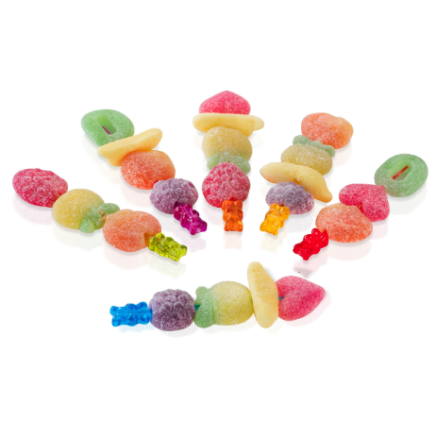
p-i-é | o-c-l-a-b |  | on-b-b-on
P-I-É | O-C-L-A-B |  | ON-B-B-ON
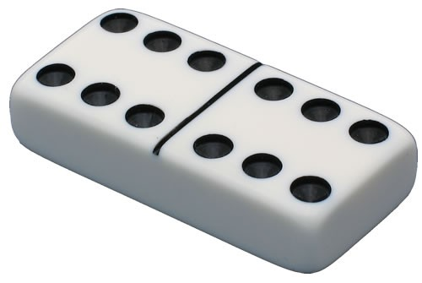 | 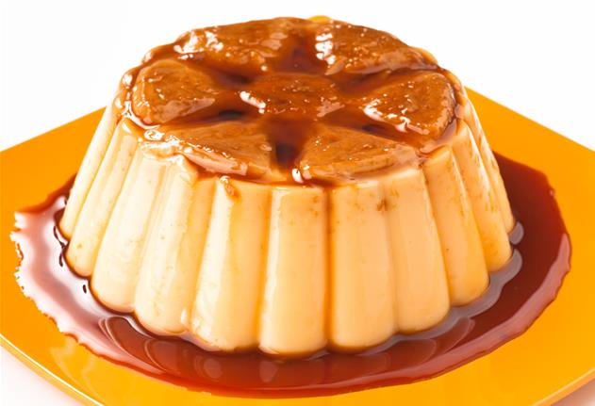 |  | 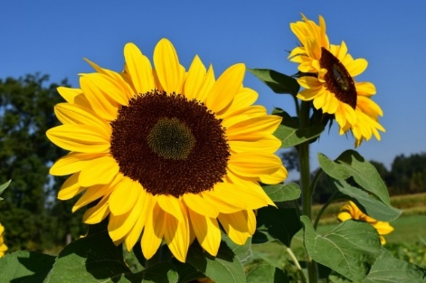
o-i-o-d-m-n | l-an-f |  | r-ou-o-s-t-e-n-l
O-I-O-D-M-N | L-AN-F |  | R-OU-O-S-T-E-N-L
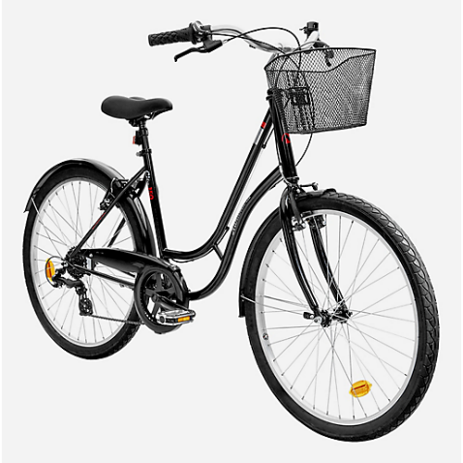
é-v-l-o | a-an-m-m | t-c-on-a-r
É-V-L-O | A-AN-M-M | T-C-ON-A-R
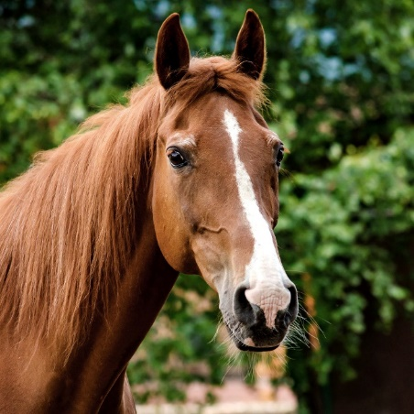 | 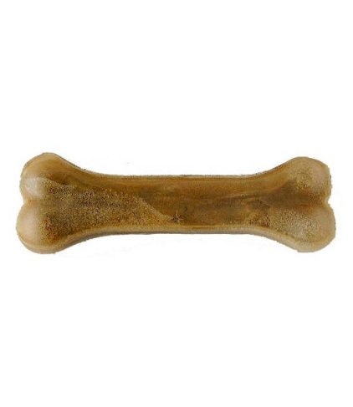 |  | 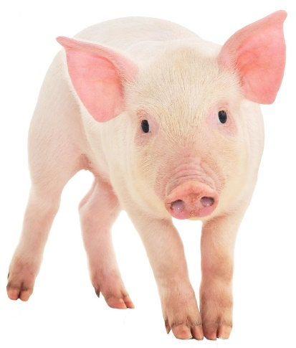
v-a-ch-e-l | s-o |  | c-o-on-ch
V-A-CH-E-L | S-O |  | C-O-ON-CH
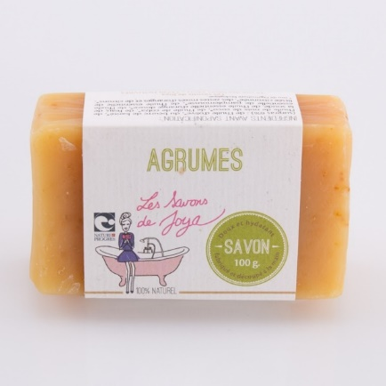 | 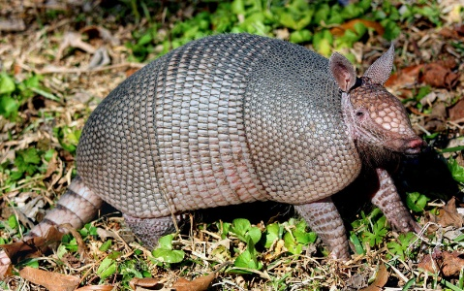 |  | 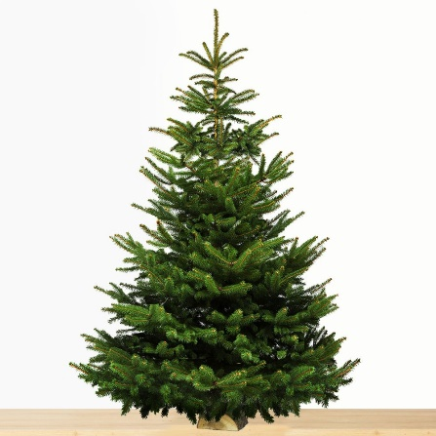
v-a-s-on | t-ou-t-a |  | p-a-s-in
V-A-S-ON | T-OU-T-A |  | P-A-S-IN
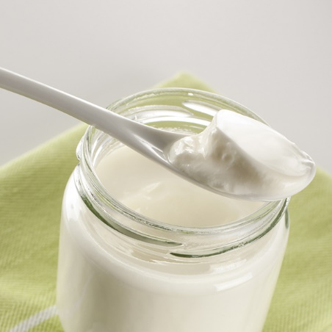 | 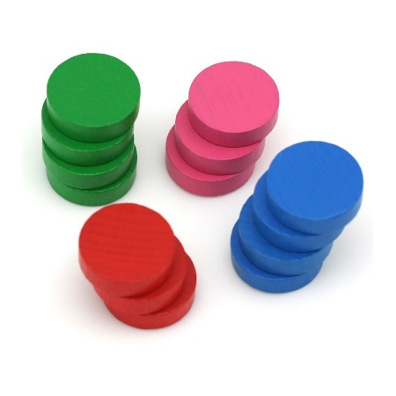 |  | 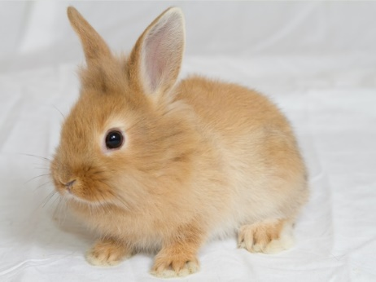
ou-r-y-t-a | t-e-j-on |  | p-l-in-a
OU-R-Y-T-A | T-E-J-ON |  | P-L-IN-A
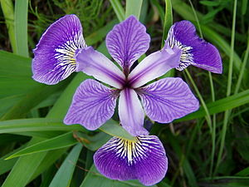 | 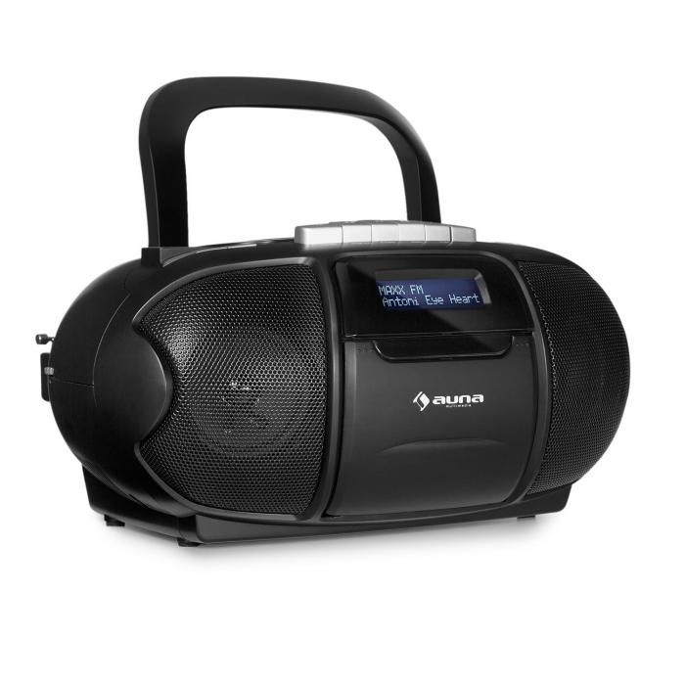 |  | 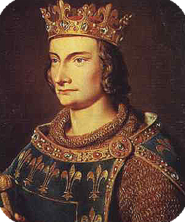
s-i-r-i | d-i-r-a-o |  | oi-r
S-I-R-I | D-I-R-A-O |  | OI-R
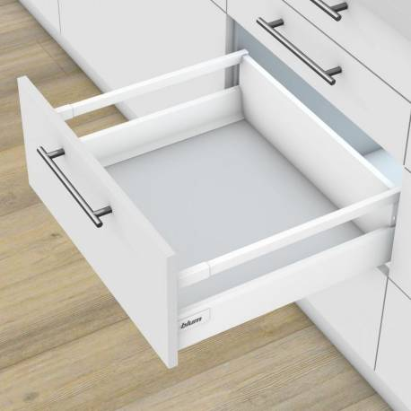 | 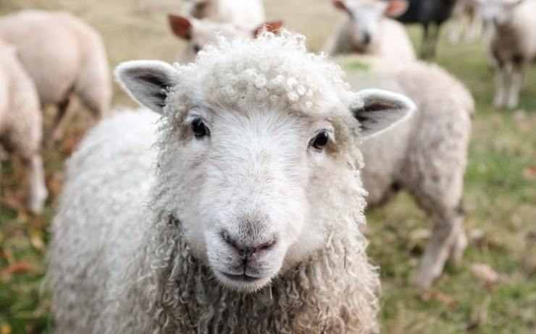
r-oi-t-i-r | t-ou-on-m |  | t-on-b-ou
R-OI-T-I-R | T-OU-ON-M |  | T-ON-B-OU

